**Setup Menu**

# Hew Lines VA7HU and Aki Yoshida JA1NLX

## 1.0 General

## 14.0 UPDATES MENU ITEM

The **Updates** menu item provides the capability to configure and enable the Update functions of Logger32.

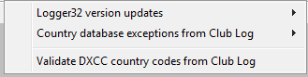

SM_17

### 14.1 Logger32 Version Updates

The “Logger32 version updates” brings Logger32 up to the latest public release. This update can be set to run automatic or manual. If the automatic update option is selected, Logger32 will automatically poll the internet location 10 seconds after each startup of Logger32. The manual update can be initiated at operator discretion. You can also read the latest release notes.

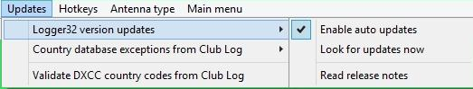

SM_17A

## 14.2 Country Database Exceptions

The "Country database exceptions" will update the Logger32 country database to match the Club Log database. This will update both the PFX and callsign exceptions. ~~This will be repeated daily if~~  If "Enable auto update' is checked, it run as a background process, has no window and will run 10 seconds after you start Logger32. ~~or~~ If you ~~should~~ ~~run~~ click "Look for updates now" ~~at least weekly.~~  it will start to update and show the window

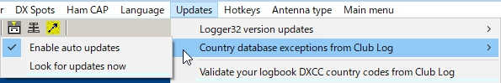

SM_17B

**14.3 ~~14.2~~ Validate DXCC Country Codes**

The "Validate DXCC country codes" will update the user logbook to show the proper DXCC assignment. This validation is based on the Club Log knowledge base and are based on the actual time periods of specific operations. This option can be run automatic or manually at operator discretion. If manual mode is selected, the operator will be prompted for approval where Logbook differs from the Club Log record. If the user has evidence such as QSL card supporting validity of the logbook record, it is suggested that the evidence be presented to the Club Log help desk so they can update their records. There is also an option to leave the logbook records as is when the QSO already has ARRL confirmation.

This validation updates the statistics automatically unless the operator chooses to do it later to speed up the process.

**Note**: This function modifies your Logbook records. Recommend a full logbook backup before proceeding.

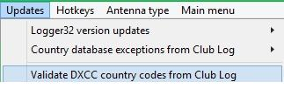

SM_17C

## 15.0 HOTKEYS MENU ITEM

The **Hotkeys** menu item provides a list of items that can be "checked" to enable global hotkeys within Logger32. The default setting is off (not checked and it is recommended that if you don't use hotkeys, you leave them off.

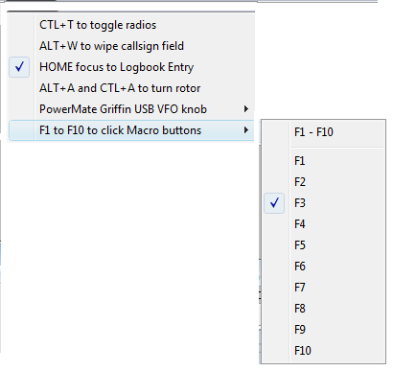

SM_18

## 16.0 ANTENNA TYPE MENU ITEM

The **Antenna Type** menu item provides the capability to select either the SteppIR antenna controller or the Ultra Beam antenna controller..

## 17.0 MAIN MENU ITEM

The **MAIN MENU** menu item allows the user to switch back to the Main Menu bar.